Ujian Akhir Praktikum - Semester Ganjil 2020/2021
Practicum Final Exam –Odd Semester Year 2020/2021
Matakuliah  Subject |  |  | COMP6153 – Operating System |  |  | 
Kelas  Class | : | BB08 |  | Tanggal Mulai  Start Date | : 19 December 2020
Kelas  Class | : |  |  | Waktu Mulai  Start Time | : 13.20
Dosen  Lecturer | : | D6353 - Michael Wairisal, S.Kom, M.TI |  | Tanggal Selesai  End Date | : 19 December 2020
Dosen  Lecturer | : |  |  | Waktu Selesai  End Time | : 15.20

PERATURAN UJIAN:
Exam Regulations:
- Mahasiswa tidak diperbolehkan berdiskusi dan/atau bekerja sama dengan peserta ujian lainnya
Student is not allowed to discuss and/or work together with other exam participants
- Mahasiswa tidak diperbolehkan untuk membuka dan menyalin dari BUKU atau CATATAN, VIDEO dari pengajar (recording kelas, VBL, Youtube, dsb) dan REFERENSI lainnya
Student isn't allowed to open and copy from any resources such as notes, videos (class recording, VBL, Youtube, etc) and other references
- Mahasiswa tidak diperbolehkan membuka dan menyalin jawaban dari internet (google, stackoverflow, dsb)
Student isn't allowed to open and copy answer from the internet (google, stackoverflow, etc)
- Asisten BERHAK memberi nilai 0 (NOL) bagi peserta ujian yang melakukan segala bentuk kecurangan
Assistant is able to give 0 (ZERO) score for exam participant who does any cheating actions
- Kumpulkan jawaban tepat pada waktunya, apabila terlambat mengumpulkan maka jawaban tidak akan dikoreksi dan nilai mahasiswa adalah 0
Submit the answer on time, if not, then the answer will not be checked, and the students will receive 0 (ZERO)
- Bila Anda tidak membaca peraturan ini, maka Anda dianggap telah membaca dan menyetujuinya
If you have missed to read these regulations, so you are considered to have read and agreed on it



SOFTWARE YANG DIGUNAKAN:
Software will be used:
- Java 8
- Eclipse 2020.6
- NachOS 5.0j

FILE YANG DIKUMPULKAN:
File must be collected:
- JAVA
- CLASS

PERHATIAN!
Attention!
- Bagi yang mengerjakan tidak sesuai dengan soal, maka akan diberikan nilai NOL (0)
For those who do not work in accordance with the exam case will be marked as ZERO (0)
- Bagi yang mengerjakan tidak sesuai dengan software dan versi yang telah ditetapkan, maka akan tetap dikoreksi dengan software dan versi yang telah ditetapkan
For those who do not work in accordance with the software and specific version will be corrected by the predefined software and version
- Kompres semua jawaban yang akan diunggah. Pastikan format pengumpulan nama file dan ekstensi sesuai dengan format berikut: [NIM]-[NAMA].zip
Compress all file that will be uploaded. Make sure the format for collecting file name and extension according to the following format: [NIM]-[NAME].zip

Soal
Case

Important Notes:
- Use your own Console and Scheduler (FIFO)
- You must use Semaphore to control operation
- You must use Timer to generate tick of time
- Use KThread

Bluejack PC Component Store
Bluejack PC Component Store is a PC Component Store that is famous on the BlueJack land, the Storekeeper wanted to make an application that can manage items that will be delivered. The features provided in this application are insert, view, and deliver the items. you are asked to create the application using nachOS in Java programming language.
In the start of the application, the program will look for a file named “PCComponent.txt” which will be converted into list of the items on the store and load it to our system with the help of file system if the file is available.
After the process has been completed, the application will then show 4 menus which represents feature in the application, which are:
- Add Component
- View Component(s)
- Deliver
- Exit
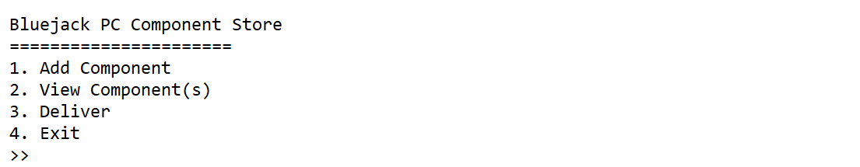
Figure 1. Main Menu
Important Notes:
- Use your own Console and Scheduler (FIFO).
- You must use Semaphore to control operation.
- You must use Timer to generate tick of time.
- Use KThread.
- Add item
The first menu option let the user insert a new component into the system. This option requires the user to input information regarding the item with the following detail:
- Ask the user to input Component’s name. The component’s name must be between 3 and 50 characters and contains only alphabets and spaces.
Figure 2. Component’s name input
- Ask the user to input Component’s category. The component’s category must either Storage, Display, or Basic Component (case sensitive)
Figure 3. Component’s category input
- Ask the user to input Address where to send the component. The address must ends with “ Street”
Figure 4. Address input

- After all the required input has been filled, save the input file named “PCComponent.txt” with the following format and show success message to the user.
[Component’s Name]#[Component’s Category]#[Address]

Figure 5. Success

- View Component(s)
The second option of the menu allows the user to view all data read by file system. The process follows the following steps which are:
- Check if item list has any data. If the component list didn’t have any data, the application shows an error message to the user.
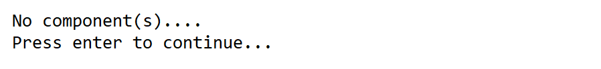
Figure 6. View validation
- Otherwise, if the component list already filled or have list of components, the application will show all files received using KThread and Scheduler (FIFO Concept). The item will be shown with delay 1000 miliseconds (using Thread sleep)

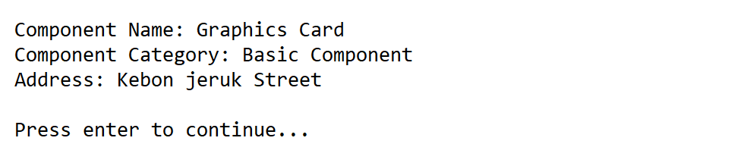
Figure 7. View all data
- Deliver
The third option in the menu allows the user to deliver all components in the list. The deleting process follows the following steps:
- Check if the component list has any data. If the component list didn’t have any data, the application will show an error message to the user.
Figure 8. Deliver validation
- Otherwise, the application will print all item on the list while removing them from the list one by one using FIFO Concept. The item will be shown with delay 1000 miliseconds (using Thread sleep).
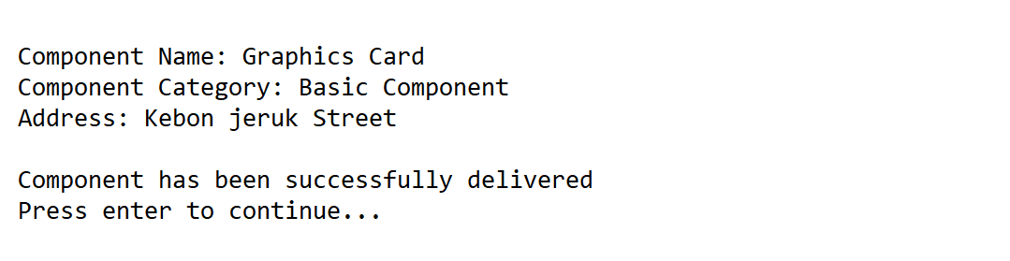
Figure 9. Deliver components
- After the component’s delivery has been completed successfully, Update the data in file “PCComponent.txt” and direct the user back to the main menu.

- Exit
If the user chooses the fourth menu, the application will print tick of time using a timer and show the user a message that says: “Thank you. Good Bye!”.

Figure 10. Exit

